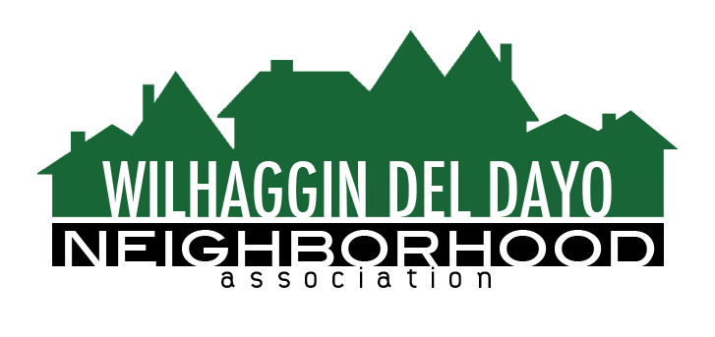

Minutes of Board of Directors
Tuesday, September 14, 2021 – 7:00 PM

The meeting was called to order on Zoom at 7:00 pm by Pat Landgraf.

Board members present were Pat Landgraf, Kathy Rodriguez, Debbie Desselle, Kathleen Newton, Maria Talcott, Brian Smith, Fern Waddell, Adam Anderson, Richard Goore
Absent: Paul Blaise, Steve Swatt
Adoption of Minutes
Minutes were approved with corrections. There was a motion (Smith) second (Newton) to approve the minutes. The motion was unanimously approved.
Membership Report
We have 18 paid members for 2022. There was a motion (Newton) second (Rodriguez) to approve the membership report. The motion was unanimously approved.
Financial Report
Rodriguez reviewed the WDDNA reconciliation detail, profit & loss, balance sheet and expenses. 58% of shifts were worked for July and 39% for August. Year to date 70% of shifts are filled. We have budget savings this year, due to Covid and the academy shutting down, that will allow us to continue the 8 hour shifts next year. Our CPA McDonald filed for an extension with IRS on time and has backup to support. There was a motion (Newton) second (Smith) to approve the financial report. The motion was unanimously approved.

OLD BUSINESS
- Crime report. There were 6 incidents. Most were residential burglaries, one vehicle, one arson.
- Patrol scheduling. In August, we had 5 vacant shifts. We filled 2 shifts. We still have 3 vacancies in our regularly scheduled shifts. Smith said the weekend shifts are not being filled. Smith can advertise two extra evening shifts.
- Marketing update. Newton said she sent letters to non members and recent residents. Mail house sent the letters two times due to a glitch with a brochure. One went out in late August. Email newsletter in October will start our new membership campaign. Reminder emails will be scheduled automatically through Zoho. Renewal invoice will go out to members who have not paid in early Nov. 19 members get regular mail.
Brochure will go out mid-Dec through regular mail.
- Marketing communications. Newton explained that some members did not receive emails sent via the Zoho system, so we have switched back to Constant Contact until we can resolve the problem. She described several methods she will work on to improve deliverability so we can resume the use of Zoho emails in the future.
NEW BUSINESS
- Town Hall. Landgraf said we are on the calendar at Jesuit for a room reservation.
- Next meeting, October 12, 2021 at a board member’s house.

ADJOURN Meeting 8:00 pm
Submitted by Debbie Desselle, Secretary on September 23, 2021.

