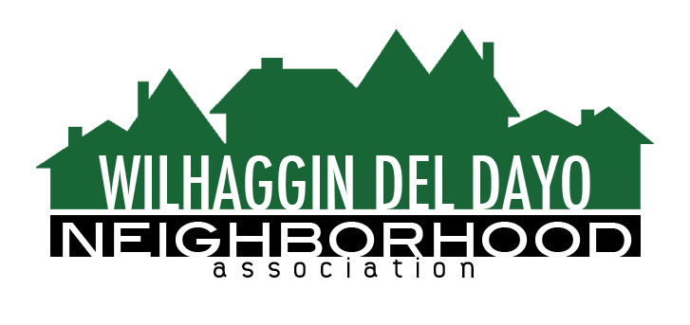

Minutes of Board of Directors
Tuesday, October 12, 2021 – 7:00 PM

The meeting was called to order on Zoom at 7:00 pm by Paul Blaise.

Board members present were Paul Blaise, Pat Landgraf, Debbie Desselle, Kathleen Newton, Maria Talcott, Brian Smith, Fern Waddell, Adam Anderson, Richard Goore, Steve Swatt
Absent: Kathy Rodriguez
Adoption of Minutes
Minutes were approved with corrections. There was a motion (Newton) second (Waddell) to approve the minutes. The motion was unanimously approved.
Membership Report
We have 261 paid members for 2022. There was a motion (Smith) second (Newton) to approve the membership report. The motion was unanimously approved.
Financial Report
Waddell reviewed the WDDNA reconciliation detail, profit & loss, balance sheet and expenses. IRS hasn’t responded yet to our CPA correspondence. For Sept our income and expenditures are almost equal. In Sept we spent $22,000.00 and 8 days were not filled. 65% of shifts were worked for Sept. 48% of shifts were worked for August. We reduced our budget by adding 2 hours to our shifts. There was a motion (Landgraf) second (Newton) to approve the financial report. The motion was unanimously approved.

OLD BUSINESS
- Crime report. There were 2 incidents that were reported in Lexis Nexus. There was an attempted break in on Arden Way.
- Patrol scheduling. We increased hours in Sept. We are down to 4 vacant shifts out of 10. We have 2 deputies that worked 2 shifts each for us. Academy has 30 recruits graduating in Oct and 50 recruits will graduate in Nov. We have a shift filled every other Sat evening.
- Invoice distribution process. Invoices went out on Oct 1^{st.} Newton said the invoices are working really well. We are at 25% paid for 2022.
- Marketing campaign. Newton needs a system to download previous members who haven’t paid. Newsletter and patrol report will be sent separate. A reminder to renew will be included only to the people who haven’t paid. It can be segmented in Zoho. Regular mail will go out to non-members in Nov. Postcards will go out for non-members advertising town hall.
NEW BUSINESS
- Town Hall. Landgraf said we are on the calendar at Jesuit for a room reservation for Dec 8. Jesuit follows the mask mandate.
- Future board members. Andersen said we could make an announcement at town hall to recruit potential board members. Talcott said she may reduce her duties next year and suggested a volunteer to input checks.
- Next meeting, November 9, 2021 at a board member’s house.

ADJOURN Meeting 8:00 pm
Submitted by Debbie Desselle, Secretary on November 3, 2021.

