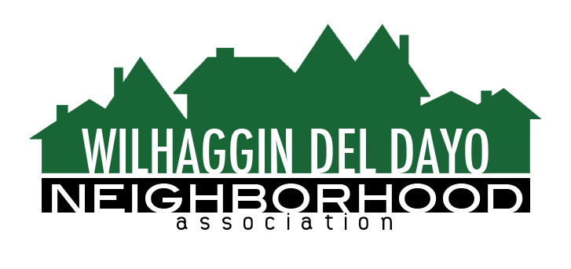

Minutes of Board of Directors
Tuesday, November 9, 2021 – 7:00 PM

The meeting was called to order at 7:00 pm by Paul Blaise.

Board members present were Paul Blaise, Pat Landgraf, Debbie Desselle, Kathleen Newton, Brian Smith, Fern Waddell, Adam Anderson, Richard Goore, Steve Swatt, Kathy Rodriguez
Absent: Maria Talcott
Adoption of Minutes
Minutes were approved. There was a motion (Newton) second (Goore) to approve the minutes. The motion was unanimously approved.
Membership Report
We have 365 paid members for 2022. Zoho is working well. We may be ahead of normal for early membership payments. There was a motion (Anderson) second (Swatt) to approve the membership report. The motion was unanimously approved.
Financial Report
Rodriguez reviewed the WDDNA reconciliation detail, profit & loss, balance sheet and expenses. IRS hasn’t responded yet to our CPA correspondence regarding tax penalty. We had 57% of shifts worked for October and 57% worked YTD. We will have remaining 2021 dues to use for expanded hours and possible sheriff rate increase next year. We moved all 2022 dues to savings and will continue to transfer all online dues into savings. We are within budget for marketing. There was a motion (Newton) second (Landgraf) to approve the financial report. The motion was unanimously approved.

OLD BUSINESS
- Crime report. There were 2 incidents that were reported in Lexis Nexus. There was a larceny on Lantern Ct, and one motor vehicle part theft. 3 incidents in Arden Park.
- Patrol scheduling. We are down 3 shifts. We have 3 deputies that worked 3 shifts each for us. We haven’t been able to fill our extra shifts we advertised.
- Annual Meeting. We fully anticipate a rate increase in 2022. People may be able to relate to why we are having trouble filling shifts. Newton said we can look at other investments such as speed signs. American River Dr does not have enough speed limit signs. Rio and Jesuit traffic cause big problems for the neighborhood traffic.
- Annual Meeting Run of Show. Blaise reviewed the Run of Show for Annual Meeting. Board member name tags will be provided. We need signage for directions to the gym. There is a new sound system. We will have two microphones. Masks are required. Newton found a video service that can make a video for $500.00.
- Requesting Help. We get volunteers but we don’t have a specific job for people. We do need a data entry person. We need to estimate hourly time commitment. Zoho is accessible for everyone. Time lag is entered into Zoho. Checks are brought to Rodriguez. We don’t know if PaySafe enters the data a day or two later.

NEW BUSINESS
- Next meeting, January 11, 2022 at a board member’s house.

ADJOURN Meeting 8:00 pm
Submitted by Debbie Desselle, Secretary on January 5, 2022.

