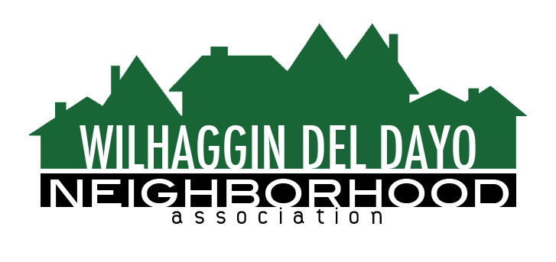

Minutes of Board of Directors
Tuesday, May 8, 2022 – 7:00 PM

The meeting was called to order by Zoom at 7:05 pm by Paul Blaise.
Board members present were Paul Blaise, Pat Landgraf, Debbie Desselle, Kathleen Newton, Kathy Rodriguez, Brian Smith, Fern Waddell, Richard Goore, Maria Talcott by phone call, Steve Swatt by Zoom
Absent: Adam Andersen
Adoption of Minutes
Minutes were approved. There was a motion (Newton) second (Waddell) to approve the minutes. The motion was unanimously approved.
Membership Report
We have 1023 paid members for 2022. We had three free people. Waddell had a question about the number of paid members and matching with the records. Talcott said Zoho may be off by one membership. Talcott was asked about continued involvement with the board. There was a motion (Landgraf) second (Smith) to approve the membership report. The motion was unanimously approved.
Financial Report
Rodriguez reviewed the WDDNA reconciliation detail, profit & loss, balance sheet and expenses. 2021 taxes were filed. We still have IRS extensions for 2020. We are running under our forecast. From Jan through April our dues accrual have been spent on patrols, however we are $1500.00 under our actual accrual for dues. We have not had to use the money market. Sheriff Patrols – March 76% /April 54%. There was a motion (Newton) second (Landgraf) to approve the financial report. The motion was unanimously approved.
OLD BUSINESS
- Incident report. Blaise reviewed the crime report. There was 1 incident. Arden Park-0, Sierra Oaks-0.
There has been an uptick in vehicle thefts. Smith said YTD we have recorded 4 thefts and two of the vehicles have been recovered.
- Patrol Shifts. We lost our Saturday day shift, but we gained a Monday night shift. We have 4 shift vacancies we are trying to fill. Weekend shifts are only being filled every other week.
- Off duty. We will have no rate increase for July. There may be an increase in the Fall.
- River Walk Way. Newton said there isn’t an update. Liz Bellas, Head of Parks Dept., said she hasn’t heard any updates regarding funding from Desmond for an electric gate. She contacted the Sheriff’s Department to get their feedback about adding a gate, but has not had a response yet.

NEW BUSINESS
- Parking issues at Rio. Rio installed the entrance gate early and this will decrease the amount of reckless driving after hours at Rio. There has been an escalation in parking issues at Rio Americano HS. Many students are parking on Bailey, Saverien and other residential streets. Newton said we need to try and address the situation by working on the behalf of the WDDNA members. We can request an open forum and ask Desmond to attend.
- Email opening rate. Newton said our email readership rate went up. We are up to 70% readership. Newton is writing and covering interesting articles and membership may be up because of it.
- Fall marketing. Newton asked if we have any input on tweaking our marketing campaign for the fall.
We will start with email and then move onto hard copy and invoices.
- Town Hall. Landgraf asked for potential town hall dates at Jesuit. We suggested Dec 6th or 7th.
- Next meeting, June 14, 2022 by Zoom.

ADJOURN Meeting 8:10 pm
Submitted by Debbie Desselle, Secretary on June 9, 2022.

