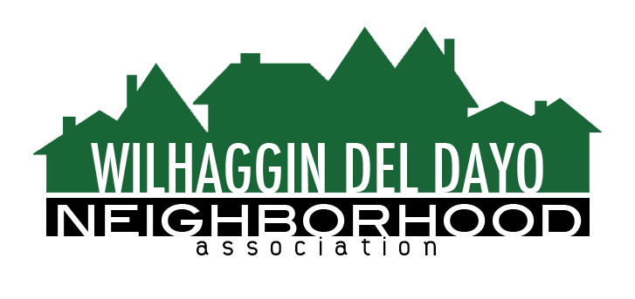

Minutes of Board of Directors
Tuesday, May 11, 2021, 2021 – 7:00 PM

The meeting was called to order at 7:00 pm by Paul Blaise by Zoom.

Board members present were Paul Blaise, Pat Landgraf, Kathy Rodriguez, Kathleen Newton, Maria Talcott, Brian Smith, Fern Waddell, Steve Swatt, Adam Anderson, Richard Goore

Adoption of Minutes
Minutes were approved with corrections. There was a motion (Newton) second (Waddell) to approve the minutes. The motion was unanimously approved.

Membership Report
Membership remains the same, 975 paid members for 2021.There was a motion (Newton) second (Rodriguez) to approve the membership report. The motion was unanimously approved. Maria doesn’t feel comfortable handing off the membership job until the web site transition is complete. Since she now has help she would consider staying on. Goore will be handling new Members and Anderson will handle the PO Box and emails.

Financial Report
Rodriguez reviewed the WDDNA reconciliation detail, profit & loss, balance sheet and expenses. Landgraf and Rodriguez met to make a board recommendation with extra money we have. Looking at a $12,000 savings it was decided that we could increase 2 shifts an additional 2 hours per week. This will give us 2-8 hour shifts without pulling from funds in reserve. There are still some additional funds that could then be used for the Zoho program, should they be needed. The Friday and Saturday shifts were expanded 7 p.m. to 3 a.m. starting April 23rd. Only 75% of our April shifts were filled. There was a motion (Waddell) second (Swatt) to approve the financial report. The motion was unanimously approved.

OLD BUSINESS
- Crime Report. No new incidents were reported in the past 30 days.
- Zoho integration. Newton said they have found more items that need tweaking. She feels they will need more training after this is done. There have been some communication things that have come up between word press and Zoho. Newton estimates the additional cost will be somewhere between $1,000 and $1,500 to wrap everything up. A date of July 1st will be our drop-dead date for the switch over, however we plan to be done before then.
NEW BUSINESS
- Since we take credit cards for our renewals, we have compliance rules that need to be followed for credit card security practices. PCI is the group that sends out the Organizational Safety Plan. Newton has filled out the paperwork and we voted to accept this plan on 5/11/2021.
- Discussion on putting AB 122 in our news letter (Stop Sign becomes a Yield for bike riders) It was decided since we have, so many bike riders in this area we would make them aware that this is in process at the Capital. We will not take sides or make it a political issue just state the fact that it is being considered. Future items such as this will be discussed by the board before being put in the Newsletter.
- Next meeting, June 8,2021by Zoom.

ADJOURNMeeting 7:25pm
Submitted by Pat Landgraf, V.P. on May 11, 2021.

