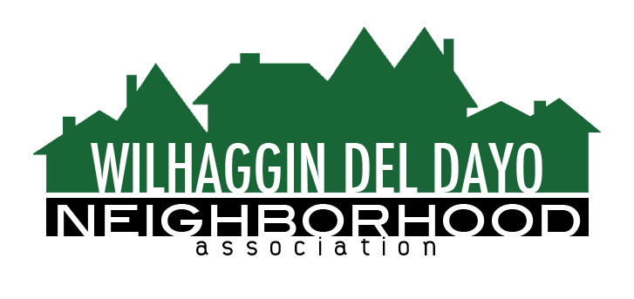

Minutes of Board of Directors
Tuesday, March 9, 2021, 2021 – 7:00 PM

The meeting was called to order at 7:00 pm by Paul Blaise by Zoom.

Board members present were Paul Blaise, Pat Landgraf, Debbie Desselle, Kathy Rodriguez, Kathleen Newton, Maria Talcott, Brian Smith, Fern Waddell
Absent: Steve Swatt
Guests: Adam Anderson, Richard Goore

Adoption of Minutes
Minutes were approved with corrections. There was a motion (Newton) second (Waddell) to approve the minutes. The motion was unanimously approved.

Membership Report
We have 972 paid members for 2021, 2 new members. There was a motion (Landgraf) second (Rodriguez) to approve the membership report. The motion was unanimously approved.

Financial Report
Rodriguez reviewed the WDDNA reconciliation detail, profit & loss, balance sheet and expense Report. 80% of shifts were worked in Jan. and 75% worked in Feb. We changed to interest bearing checking. There was a motion (Waddell) second (Newton) to approve the financial report. The motion was unanimously approved.

OLD BUSINESS
- Crime Report. We had one incident at a vacant house on Del Dayo Dr.
- Patrol expansion. Smith reported that daytime shifts were increased an extra two hours on Tuesday, Wednesday, Thursday, and Friday. The emphasis is to concentrate on traffic related issues for the extra two hours and patrols are issuing more citations.
- Zoho integration. Talcott said the Zoho associate has not had contact with her. They will set up a meeting so we are not delayed in uploading master contact list spreadsheet. Goore and Anderson will be included in the call. Newton is building templates to use for our email transitions. Smith will upload one year’s worth of the old newsletters and patrol reports.
- Website rebuild. We have a draft website currently being built on Hostgator.
- Merchant card processing group. Credit card processing is being integrated into Zoho.
NEW BUSINESS
- RV. An unoccupied RV continuously parks in our neighborhood moving around from street to street every 72 hours. Smith will ask the night patrols to check the RV overnight and make contact.
- Next meeting, April 13, 2021 by Zoom.

ADJOURN Meeting 7:40 pm
Submitted by Debbie Desselle, Secretary on April 5, 2021.

