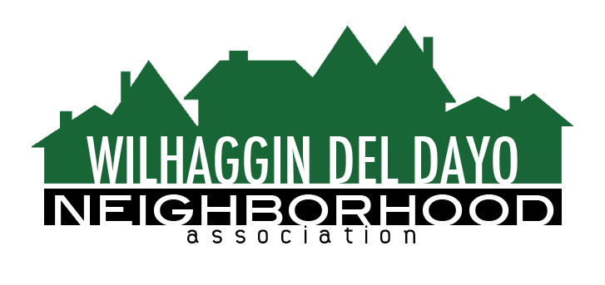

Minutes of Board of Directors
Tuesday, June 14, 2022 – 7:00 PM

The meeting was called to order on Zoom at 7:05 pm by Paul Blaise.
Board members present were Paul Blaise, Pat Landgraf, Kathleen Newton, Brian Smith, Fern Waddell, Steve Swatt,&
Adam Andersen. Richard Gore will be stepping down due to his busy schedule. We will need to find someone to do the welcome wagon.
Adoption of Minutes
Minutes were approved. There was a motion (Newton) second (Swatt) to approve the minutes. The motion was unanimously approved.
Membership Report
We have 1024 paid members for 2022. We have three free members. There was a motion ( ? ) second ( ? ) to approve the membership report. The motion was unanimously approved.
Financial Report
Fern reviewed the WDDNA profit & loss. The income and the Sheriff expenses match. The cash agrees with operations. Our income plus interest = what is in our checking account., so the account is balanced.. The sheriff credited us for an over payment – At this point we should be at 42% sheriff expenses for the year. There was a motion (Newton) second (Smith) to approve the financial report. The motion was unanimously approved.
OLD BUSINESS
- Incident report. Blaise reviewed the crime report. There was 1 incident. Theft from a building, on American River Drive. Arden Park-0, Sierra Oaks-1, and Shelfield 0.
- Patrol Shifts. We have 4 vacancies every other week. Two deputies are out on Medical Leave. We had a sub on Sat June 4th.
- There are 33 Sheriff trainees in the May class, 49 in the August training Class and 55 in the December training class. However not all of these grads will go to our Sheriff Department.
- The sheriff’s can make more money working overtime than working the off duty rate, however our work is quite a bit easier. We will see what happens in the future.

NEW BUSINESS
- New Membership Guide, Kathleen did an excellent job. The booklets will be mailed on Thursday or the first of the next week. They take 3 days to process. The next News Letter will provide it in a PDF format, so people can down load and keep. It will also be on the web site. The cost is $1,000 to mail and $800 to print.
- Parking issues at Rio. Some WDDNA members and Officer Forsyth, one of our off Duty Sheriffs, met with Cliff Kelly and Frank Carmada.from Rio, to discuss the parking situation at the High School. Rio is working on remodeling some of the classrooms and restructuring the teachers parking in that area. They are also planning on getting rid of a trailer and reconfiguring the parking lot. They are looking at 50-75 more parking spaces. Some of this will be done by reducing the number of parking spaces they sell to seniors. Daily there are apx. 90 cars parked on surface streets around the school. The school is also planning on writing an article in their News Letter to bring awareness to STOP sign runners and bring awareness that the students are part of our community and their actions reflect on the school. He will give Kathleen a copy when the letter is completed.
- Our Town Hall date this year will be Tuesday, December 6th at JHS.
- Next meeting, July 12, 2022 location to be decided.

ADJOURN Meeting 8:20 pm
Submitted by Pat Landgraf V.P. on July 7, 2022.

