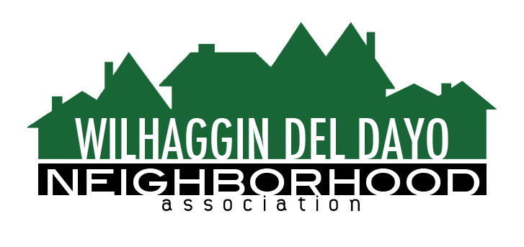

Minutes of Board of Directors
Tuesday, July 13, 2021, 2021 – 7:00 PM

The meeting was called to order at 7:06 pm by Kathleen Newton.

Board members present were Kathy Rodriguez, Debbie Desselle, Kathleen Newton, Maria Talcott, Fern Waddell, Steve Swatt, Adam Anderson, Richard Goore
Absent: Paul Blaise, Brian Smith, Pat Landgraf

Adoption of Minutes
Minutes were approved with corrections. There was a motion (Waddell) second (Anderson) to approve the minutes. The motion was unanimously approved.

Membership Report
We have 3 more paid members, and 978 paid members for 2021.There was a motion (Rodriguez) second (Swatt) to approve the membership report.The motion was unanimously approved.
Financial Report
Rodriguez reviewed the WDDNA reconciliation detail, profit & loss, balance sheet and expenses.Landgraf and Rodriguez met to discuss excess budget. State and federal taxes were filed by accountant. Only 44% of our June shifts were filled. Rodriguez said we are running under budget. We can use excess of $15,000.00 if we increase some shifts from 6 to 8 hours. There was a motion (Waddell) second (Goore) to approve the financial report. The motion was unanimously approved.

OLD BUSINESS
- Crime Report. No new incidents were reported in the past 30 days.
- Zoho integration. Newton said the new website is up and running after the public domain registry activated our registration.
- Firework complaint. There was a complaint regarding the fireworks from July 4.
- Vacant patrol shifts. Newton said only 5 out of 10 shifts are currently being filled. There are numerous reasons such as deputy absences and sheriff’s department shift changes. There are 92 vacant sheriff positions. Two classes of trainees from the academy will graduate in November.
- Newsletter notice. There will be an article in our newsletter regarding vacant shifts and the vacant sheriff positions. We will also increase our shifts from 6 to 8 hours.
- Password concerns. Talcott is going to research the passwords to make sure they are working. Some members are not able to log in.
NEW BUSINESS
- Marketing campaign. Newton said we normally send letters to former members,in August, as a target audience. Anderson said he will filter for the dates in Zoho of non-members.
- Invoice reminder. Invoices will be mailed in November to members who haven’t renewed. We can encourage on-line payment.
- Town hall. Newton will ask Jesuit if they are open for in person meetings.
- Traffic increases. We have been having problems with an increase in traffic and people running stop signs. Newton said the traffic committee will schedule another meeting with CHP.
- Next meeting, August 10, 2021 at a board member’s house.

ADJOURNMeeting 8:35 pm
Submitted by Debbie Desselle, Secretary on August 4, 2021.

