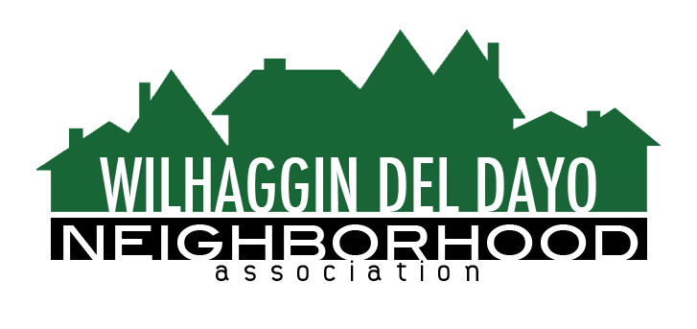

Minutes of Board of Directors
Tuesday, February 8, 2022 – 7:00 PM by Zoom.

The meeting was called to order by Zoom at 7:05 pm by Paul Blaise.
Board members present were Paul Blaise, Pat Landgraf, Debbie Desselle, Kathleen Newton, Kathy Rodriguez, Brian Smith, Fern Waddell, Maria Talcott, Steve Swatt
Absent: Adam Andersen, Richard Goore
Adoption of Minutes
Minutes were approved. There was a motion (Newton) second (Rodriguez) to approve the minutes. The motion was unanimously approved.
Membership Report
We have 1014 paid members for 2022. We may hit 1020 soon. We have 47% participation rate. We only lost 5%. There was a motion (Newton) second (Swatt) to approve the membership report. The motion was unanimously approved.
Budget meeting.
Budget meeting was held. We estimate 10 shifts of 8 hours each with an 11% increase and 85% of shifts worked. Zoho ECS increased to $700.00. Invoices were merged into membership campaign. Talcott said we can count on more revenue from new members signing up. We plan to reduce our surplus to $56,000.00. There was a motion (Smith) second (Landgraf) to approve the budget report. The motion was unanimously approved.
Financial report.
Rodriguez reviewed the WDDNA reconciliation detail, profit & loss, balance sheet and expenses. Rodriguez said the IRS continues to say they need more time to review our taxes for 2021. Our accountant may be filing an extension on our taxes annually. We need to urge him to pay our taxes timely this year and not file an extension. There was a motion (Newton) second (Waddell) to approve the financial report. The motion was unanimously approved.
OLD BUSINESS
- Incident report. Blaise reviewed the crime report. There was a total of 9 incidents. Arden Park-0, Sierra Oaks-5. Many ranged from burglaries and theft of vehicle parts. We had 15 for the whole year in 2021. We have warmer weather and may have more people reporting their crimes. Many car thefts happen at night. Smith said we have filled our Monday night shift. An arrest was made at Estates and American River Dr.
- Traffic committee update. A group of board members met via Zoom with Lu Li, Principal Civil Engineer, and Sonia Hernandez, Senior Transportation Engineer, of the Department of Transportation in January. Discussion points were Rio traffic, speed bumps and more signs, ARD speed survey and River Walk Way.
- River Walk Way gate closure. Newton said she will look into having a gate installed which the deputies can open. They do have a staff that opens and closes the gates each night.
NEW BUSINESS
- Speed trailers. CHP had a maximum effort day at Rio. Speed trailers have recently been seen in the WDDNA boundaries. Newton can speak to someone with the County to see who placed these signs and do a newsletter article. Our town hall may have influenced these signs being placed in the neighborhood. Newton has looked into purchasing a speed sign but they are smaller and cost $2,000.00 to $3,000.00.
- Home security. We have had several members ask for a deputy to visit their homes and check them for things they can do to improve the house’s security. We offer this service to members at no charge.
- License plate readers (LPR). Blaise received a letter about LPR by a marketing person and said there is a new LPR in a Carmichael neighborhood called Riverwood.
- Illegal Fireworks. Blaise said Lee Miller requested our help with the illegal fireworks. We cannot get involved because it is a political action group.
- SMUD impersonators. Newton heard about an unusual crime. Two men pretending to be SMUD workers asked to be let into a backyard in Arden Park and they allegedly held the homeowner up at gunpoint.
- Next meeting, March 8, 2022 by Zoom.

ADJOURN Meeting 7:50 pm
Submitted by Debbie Desselle, Secretary on March 8, 2022.

