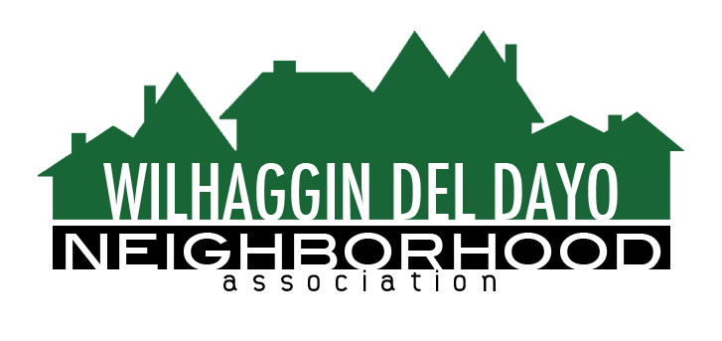

Minutes of Board of Directors
Tuesday, August 9, 2022 – 7:00 PM

The meeting was called to order by Zoom at 7:00 pm by Paul Blaise.
Board members present were Paul Blaise, Pat Landgraf, Debbie Desselle, Kathleen Newton, Kathy Rodriguez, Brian Smith, Fern Waddell, Maria Talcott, Steve Swatt
Absent: Adam Andersen Guest: Scott Murdoch, Merilee Colton
Adoption of Minutes
Minutes were approved for June. There was a motion (Swatt) second (Newton) to approve the minutes. The motion was unanimously approved.
Membership Report
We have 1030 paid members for 2022 and 1051 total members. Welcome wagon bags were distributed. There was a motion (Landgraf) second (Smith) to approve the membership report. The motion was unanimously approved.
Financial Report
Rodriguez reviewed the WDDNA reconciliation detail, profit & loss, balance sheet and expenses. June patrols worked 52% and YTD is 66%. We are running under our forecast. According to letters received from the IRS, Rodriguez believes the overdue taxes issue is resolved. So far no increase for Sheriff rate for 2022. There was a motion (Newton) second (Waddell) to approve the financial report. The motion was unanimously approved.
OLD BUSINESS
- Incident report. Blaise reviewed the crime report. There were 3 incidents. 1 robbery, 1 burglary and 1 vehicle theft. Arden Park-2, Sierra Oaks-0.
- Patrol Shifts. Smith said we continue to recruit for Fri and Sat night. We have patrols on vacation and injuries. There are 4 vacancies each week. Smith says we have already tried offering new shifts however, they continue to be unfilled. An off-duty rate increase may help our shifts look more attractive to patrols.

GUEST PRESENTATION
Scott Murdoch joined us from the American River Parkway Foundation. He reported that 594 homeless were counted in a 3-mile area of the parkway. He explained that two ordinances are being introduced by the County Board of Supervisors. One prohibits camping from sunset to sunrise on the ARP and Dry Creek Parkway. The other prohibits camping within 25 feet of critical infrastructure.

NEW BUSINESS
- Following Murdoch’s presentation, Newton said she would send an alert to WDDNA members letting them know about the Aug. 10 Board of Supervisors meeting at which the camping ordinances would be discussed.
- Welcome wagon. Talcott asked if Colton can have access to our Zoho account so she can input new member information. Colton has a lot of experience with Constant Contact and many other database programs. She wants to help out in the community. The board agreed to allow her to use Zoho.
- Newton said WDDNA member Kyle Hoertsch again proposed that WDDNA purchase LPR cameras to monitor traffic in the neighborhood. Hoertsch sells those cameras. Newton said privately owned cameras do not link into the Sheriff’s Department system and we would have to monitor them. We don’t have volunteers available to do that.
- Marketing Plan. Newton will begin our fall marketing campaign in September starting with mailings to past members and nonmembers.
- WDDNA expansion. Rodante Way and Pajaro Court have asked to be added to our service area. The board approved the expansion.
- Next meeting, September 13, 2022 by Zoom.

ADJOURN Meeting 8:25 pm

