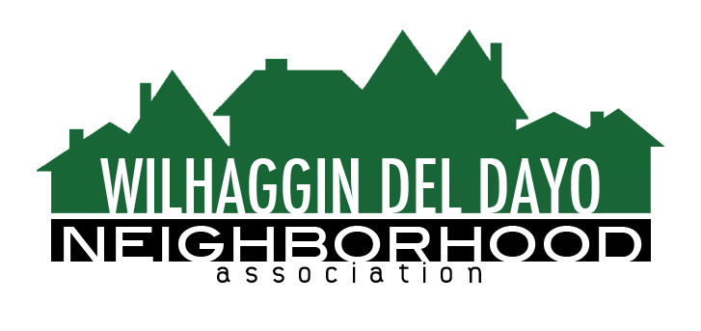

Minutes of Board of Directors
Tuesday, August 10, 2021, 2021 – 7:00 PM

The meeting was called to order on Zoom at 7:00 pm by Paul Blaise.

Board members present were Paul Blaise, Pat Landgraf, Kathy Rodriguez, Debbie Desselle, Kathleen Newton, Maria Talcott, Fern Waddell, Steve Swatt, Richard Goore, Brian Smith
Absent: Adam Anderson
Adoption of Minutes
Minutes were approved with corrections. There was a motion (Newton) second (Rodriguez) to approve the minutes. The motion was unanimously approved.
Membership Report
We have 1 more paid member, and 9 free members for 2021.There was a motion (Smith) second (Rodriguez) to approve the membership report. The motion was unanimously approved.
Financial Report
Rodriguez reviewed the WDDNA reconciliation detail, profit & loss, balance sheet and expenses. Approximately 53% of our July shifts were filled. Rodriguez said we are running under by about 21%. Year to date we are at 73% shifts worked and our budget is based on 90% of shifts worked. August Forecast shows possible spend for rest of year based on YTD spend and forecast for remaining months. Calculates sheriff shift increase from 6 to 8 hrs. Forecast based on 70% shifts worked & 80% shifts worked. Rodriguez will research credit card fees. There was a motion (Newton) second (Landgraf) to approve the financial report. The motion was unanimously approved.

OLD BUSINESS
- Crime report. There was a road rage incident that we reported in the newsletter.
- Patrol scheduling. Smith said we are down to 3 vacant shifts per week. Shifts are 8 hours each.
- Rio Americano traffic. Traffic committee met with Principal Kelly from Rio. CHP has low officer staffing currently. We only have 2 POP officers in Sacramento county. Schools have started back so Smith sent an email to our M-F deputies regarding traffic.
- Zoho CRM integration. Newton and Smith said we are still having sender issues with our email address and we need to change our setup with the unsubscribe link.
- New homeowner update. Talcott said the system works but may require follow up. If someone sells a house and they are a member it requires follow up to make sure new homeowner gets added.
NEW BUSINESS
- Lowering dues. The board decided not to lower dues since we may break even this year aside from our savings.
- Marketing campaign. Newton said we will use a mail house for addressing the envelopes. Talcott will send a mailing list which will include past members and anyone who hasn’t been a member before. We will have a post card but no door hanger. Newton suggests sending the invoice in late October. Email annual report goes out to members. We can advertise with 10 yard signs for town hall and 30 yard signs for renewal.
- Town Hall. Landgraf said we are on the calendar at Jesuit for a room reservation.
- Next meeting, September 14, 2021 at a board member’s house.

ADJOURN Meeting 8:35 pm
Submitted by Debbie Desselle, Secretary on September 7, 2021.

