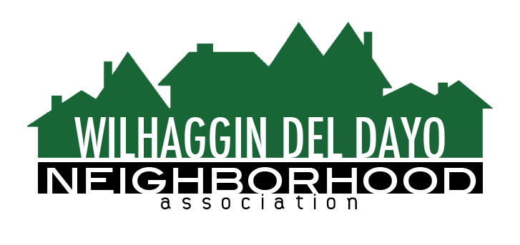

Minutes of Board of Directors
Tuesday, January 12, 2021 – 7:00 PM

The meeting was called to order at 7:05 pm by Paul Blaise by Zoom.

Board members present were Paul Blaise, Pat Landgraf, Debbie Desselle, Kathy Rodriguez, Kathleen Newton, Maria Talcott, Brian Smith, Fern Waddell, Steve Swatt
Guests: Adam Anderson, Chris Dobbins

Adoption of Minutes
Minutes were approved. There was a motion (Waddell) second (Rodriguez) to approve the minutes. The motion was unanimously approved.

Membership Report
We have 942 paid members for 2021, 83 are new members. Invoices worked well. There was a motion (Newton) second (Swatt) to approve the membership report. The motion was unanimously approved.

Financial Report
Rodriguez reviewed the WDDNA Reconciliation Detail, Profit & Loss, Balance Sheet and Expense Report. Average amount of shifts not filled for 2020 was 20%. $39,000.00 in surplus, Budget meeting will be scheduled for Feb 2 at 2 pm. There was a motion (Newton) second (Waddell) to approve the financial report. The motion was unanimously approved.

OLD BUSINESS
- Traffic issues. Newton spoke with Principal Ginter at Rio. Newton suggests we have volunteers attend a SJUSD board meeting and comment on the parking problems at Rio. Student enrollment keeps increasing, but the parking lot is not enlarged accordingly.
- 2020 Crime Report. For 2020, we had the most crime we have ever had. 43 total incidents, FBl states property crimes have gone down 69% over last 25 years. WDDNA averaged 3.6 crime incidents per month. Many were vehicle related, burglary, larceny and vacant homes. In month of December, there were 3 incidents.
- Patrol Shifts. In Nov and Dec we attempted to fill vacant positions however, most went unfilled. Smith recommends filling vacancies after 10% of vacancies haven’t been filled for the month. He suggests we hit our salary savings projections and adjust quarterly. We are averaging 8-9 vacation watches per day. In order to keep our dues at the rate they are, we will need surplus which we have currently.
- Marketing. Newton said she will send out one more letter to people who didn’t renew.
- CRM Zoho. $3,000.00 will be due. Membership module will take the longest to format. Talcott will contact Zoho to see if they need any additional lists. Newton will work on content for the new website. We may use Stripe for card processing. Zoho will present a sample demo for us using our information.
NEW BUSINESS
- Request for Assistance. Rio Senior Chris Dobbins spoke in length about his senior project and asked if we could inform our members about his Senior to Senior project. He is planning his Civitas senior project to match Rio students with elderly neighbors within the neighborhood. Students may help citizens with walks, virtual help, and registering to get the vaccine. Dobbins hopes this project may form a better relationship with Rio and the neighborhood. There was a motion (Newton) second (Talcott) to help Dobbins with his request by sending out a notice in our newsletter. The motion was unanimously approved.
- Explore Initiative in 2021. Blaise asked us to write down ideas to be addressed in Feb.
- Next meeting, February 9, 2021 by Zoom.

ADJOURN Meeting 8:15 pm
Submitted by Debbie Desselle, Secretary on February 4 , 2021.

