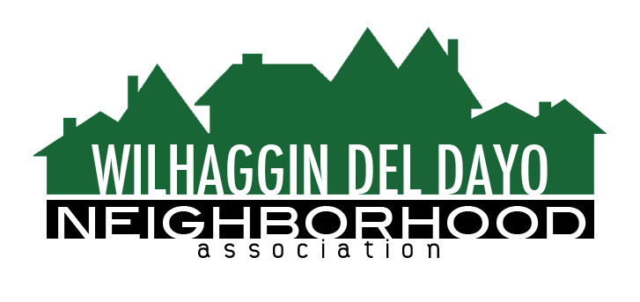

Minutes of Board of Directors
Tuesday, February 9, 2021 – 7:00 PM

The meeting was called to order at 7:05 pm by Paul Blaise by Zoom.

Board members present were Paul Blaise, Pat Landgraf, Debbie Desselle, Kathy Rodriguez, Kathleen Newton, Maria Talcott, Brian Smith, Fern Waddell, Steve Swatt
Guests: Adam Anderson, Jordan and Andrea Ollanik

Adoption of Minutes
Minutes were approved with corrections. There was a motion (Newton) second (Swatt) to approve the minutes. The motion was unanimously approved.

Membership Report
We have 970 paid members for 2021, We are at 45% enrollment with and area of 2,143 households. There was a motion (Landgraf) second (Rodriguez) to approve the membership report. The motion was unanimously approved.

Financial Report
Rodriguez reviewed the WDDNA reconciliation detail, profit & loss, balance sheet and expense report. Revenue projected to be $270,000 for 2021. The budget committee decided to leave $50,000.00 as our reserve. We can increase our patrol hours from 60 to 68 per week. Incidental expenses are email, CRM system, newsletter mail delivery, domain name, CPA, credit card fees, insurance, state fees, marketing. There may be a Sheriff’s Department off-duty hourly rate increase of 7% in July. There was a motion (Newton) second (Landgraf) to accept the 2021 budget. There was a motion (Landgraf) second (Swatt) to approve the financial report. The motions were unanimously approved.

OLD BUSINESS
- Traffic issues. Traffic will increase when schools are back in session.
- 2020 Crime Report. In January, there were 0 incidents. Arden Park has had a few catalytic converter thefts.
- Patrol Shifts. Smith suggests we increase four of our 6-hour shifts to 8 hours each to accommodate the 2021 budget. He can contact the deputies to see which ones are willing to increase their hours.
- Website conversion. We are building our new website on Hostgator and will integrate it with the CRM when it is activated.
- CRM Zoho. Newton put together materials for our new website. We are changing primary site color to royal blue. Zoho will build the site and we will populate it with the content. Our existing website email will be used for correspondence. We will get the non-profit card processing rate of 1% up to 2.6%. Talcott spoke about preparing the Excel membership spreadsheet for data transfer to Zoho. There was a motion (Smith) Talcott (second) to use Merchant Processing Group for our credit card processing.
- Timeline for CRM. Newton thinks we can integrate Zoho in late March or early April.
- Membership chairperson transition. Talcott can write a job description so incoming volunteers know what to expect. Goore can enter data from MLS.
NEW BUSINESS
- 2021 Initiatives. Major turn for the organization since we are transitioning to CRM software. Traffic committee and outreach committee were both paused due to Covid-19. Membership committee can decide if they want to continue welcome wagon. National Night Out was useful for us, but August events often are too hot for robust attendance. Door hangers were not distributed in 2020.
- Next meeting, March 9, 2021 by Zoom.

ADJOURN Meeting 8:00 pm
Submitted by Debbie Desselle, Secretary on March 4, 2021.

