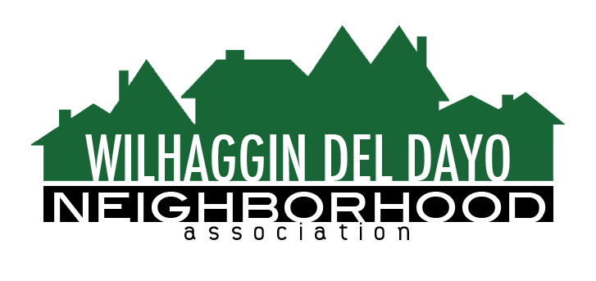

Minutes of Board of Directors
Tuesday, April 13, 2021, 2021 – 7:00 PM

The meeting was called to order at 7:00 pm by Paul Blaise by Zoom.

Board members present were Paul Blaise, Pat Landgraf, Debbie Desselle,Kathy Rodriguez, Kathleen Newton, Maria Talcott, Brian Smith, Fern Waddell, Steve Swatt
Guests: Adam Anderson, Richard Goore

Adoption of Minutes
Minutes were approved with corrections. There was a motion (Newton) second (Landgraf) to approve the minutes. The motion was unanimously approved.

Membership Report
We have 3 new members and 975 paid members for 2021.There was a motion (Newton) second (Rodriguez) to approve the membership report.The motion was unanimously approved. Welcome wagon will proceed with Goore distributing bags.

Financial Report
Rodriguez reviewed the WDDNA reconciliation detail, profit & loss, balance sheet and expense Report. Smith said there will be no patrol rate increase for 2021. 90% of shifts were worked in Feb and 84%in March. Newton suggested we increase our shifts to 8 hours since funds had been set aside for a patrol rate increase. Landgraf and Rodriguez will decide how many shifts per week can be increased to 8 hour shifts without pulling fromfunds in reserve. There was a motion (Waddell) second (Newton) to approve the financial report. The motion was unanimously approved.

OLD BUSINESS
- Crime Report. Two incidents of stolen vehicle parts and a residential outbuildingtheft were reported in the past 30 days.
- County Supervisor. Blaise, Newton, and Smith met with County Supervisor Rich Desmond who represents our district. He is the only supervisor whose district is in an unincorporated area of the county. He expressed a need to receive letters of concern from people in our neighborhood to in order to make effective change. He requests participation at Sacramento County Board meetings from citizens and urged WDDNA members to write letters of concern to county and state officials, as appropriate. He will push to keep the SCSD Off Duty Program active. Homelessnesson the American River Parkway was discussed. Desmond will be included in our member newsletters.
- Zoho integration. Talcott and Newton said the functions have been reviewed and the website and CRM integration is nearly completed with a few tweaks.Newton, Smith, Talcott, Adamson and Goore have been reviewing the CRM software and are comfortable with the process and status of integration. Board members will have the opportunity to be trained on the Zoho CRM software. The new website is not active.

NEW BUSINESS
- Member directory. The member directory on our new website may present privacy concerns because our addresses, phone numbers and email addresses are published on our website for members only. The Zoho system does not providean opt-out ability. If the content is in the Zoho software, then it is on the website. Once the Zoho integration is complete, our members will be informed that the directly info is primarily used by our deputies.
- Parking in neighborhood. In response to concern that some people are using our neighborhood to display their vehicles for sale, it is determined that, according to county law, anyone can park a vehicle along our neighborhood streets, providing it is moved within 72 hours. A citation to move allows the owner another 72 hours to move the vehicle before a fine is levied and the vehicle towed.
- Next meeting, May 11,2021by Zoom.

ADJOURNMeeting 7:55pm
Submitted by Debbie Desselle, Secretary on May 6, 2021.

